Torbain Parish Church of Scotland
e-mail: torbain.church@gmail.com
website: www.torbainchurch.org

orbain imes

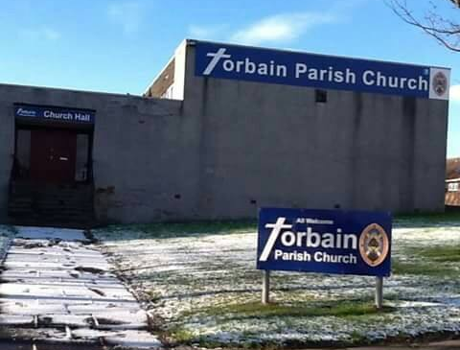

Torbain Parish Church, Carron Place, Kirkcaldy. KY2 6PS (Scottish Charity No. SC015807) Email: torbain.church@gmail.com Website: www.torbainchurch.org
(Scottish Charity No. SC015807)

Christmas Services
Sunday 20 December - 11am – Nativity Service
Thursday 24 December - 6pm - Watchnight Service

We hope to be worshipping jointly with Templehall Church on Sunday 27th December
and also Sunday 3rd January – details of services for these Sundays will be advertised on our Church Website and Facebook Page.

December 2020 Issue 50

TORBAIN CHURCH - CONTACT LIST

Ordained Local Minister – Rev.Brian Porteous (*), ‘Kildene’, Westfield Road, Cupar KY15 5DS Telephone – 01334 653561(House) 0779 669 4413(Mobile)

Session Clerk/Organist/Presbytery Elder-Gordon Thomson (*) 28 Craigearn Avenue,Kirkcaldy,KY2 6YS Telephone - 0798 512 2242

Interim Moderator Rev Graham Deans 641429

Depute Session Clerk Ken Gilbert (*) 268970

Congregational Treasurer John Bulloch (*) 0747 602 3707

Gift Aid Convenor & Printing Graeme O’Malley 261905

Free Will Offering Convenor Fiona Cunningham (*) 269297

Prayer Promoter Liz Bradley 269520

Life & Work Promoter Wendy Sinclair 202246

Safeguarding Co-ordinator Joyce Leggate (*) 264789

Safeguarding Co-ordinator Andy Leggate 264789

Community Outreach Worker (Part Time) Lauren Jones 0791 361 1018

Property Convenor Bill McMurray (*) 202173

Pastoral Care Elizabeth Pringle 266080

Hall Letting Ken Gilbert (*) 268970

Church Flowers Joyce Leggate (*) 264789

(*) – Member of Co-ordinating Group

* * * * * * * * * * * * * * * * * * * * * * * * * * * * * * * * * * * *

CHURCH ORGANISATIONS – CONTACTS

Friendship Group - Graeme O’Malley 261905

Over 60s Club - Rose Stewart 261230

Bairns,a Blether and a Brew - Lauren Jones 0791 361 1018

Bible Discussion Group by Zoom - Brian Porteous 01334 653561

Girlguiding Rangers - Marjory Aird 0776 444 7610

Girlguiding Guides - Sharon Thomson 07533 493472

Girlguiding Brownies - Irene Fairgrieve 268787

Girlguiding Rainbows - Susan Morton 205397

Little Wrigglers - Lauren Jones 0791 361 1018

The Scouts/ Cubs / Beavers - Andy Leggate 264789

(meeting in Scout Hall)

Elders’ Districts

District No. & Location Elder

- Lindores /Carron L Bradley 269520
- Lindores / Birnam M Knight 266915
- Lindores / Davaar M Forrester 571920
- G’nloanings / Torbain G Thomson (see above)
- Greenloanings/Tyndrum J Leggate 264789
- Craigmount W Sinclair 202246
- Blackcraigs/Redcraigs B&C McMurray 202173
- Glamis B MacGregor 200002
- Chapelhill M Rowan 200345

Page 2

District No. & Location Elder
10. Glens G O’Malley 261905
11 Dunnikier (1) A Stalker 206053
12 Dunnikier (2) E Pringle 266080
13 Kirkcaldy (Central) J Gallo 267561
14 Kirkcaldy (West) B Currie 641704
15 Chapel Level F Cunningham 269297
16 Oriel Rd/Newliston K Gilbert 268970
17 Sauchenbush G Blair 262479

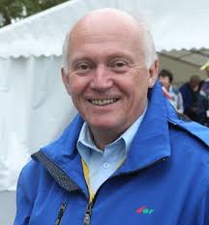
Minister’s Message

Closer to Jesus

Who would have thought we could ever have experienced a year like 2020? The almost unthinkable, a global pandemic, was the stuff of science fiction movies – until this year. We have all faced disruption to our daily lives unparalleled outside wartime – holidays cancelled, our movements curtailed, restrictions on who we meet and how we meet, theatres, cinemas and gyms closed and no hand shaking or hugging. From some, life has been even more difficult as jobs have been lost and the impact of the virus has led to illness and even, sadly bereavement. As I write this message there is hope in the form of a vaccine beginning to be a reality but we are likely to be living in this ‘new normal’ for a number of months to come.

While this has all been almost too much to cope with, I have been greatly sustained by the way in which you have all been coping, the way you have supported one another and by the patience and resilience you have shown. In the midst of all the challenges we have faced there have been many positives not least in our lives becoming a bit simpler – some of the daily pressures of busyness being relieved.

I hope too that being forced to lead simpler lives has given us time to focus more on the baby whose birthday we are getting ready to celebrate once more at Christmas. I sense that this has been a time when we have been able to feel that we are closer to our loving Saviour than we have ever been. The reality is that He is always there right beside us through the good times and the bad times – He never moves away. It is us that do the moving. I pray that you have all felt the love of Jesus surrounding you through the trials of the past year and that you will walk hand in hand with Him through the Christmas season into the New Year.

St. Paul knew a thing or two about suffering and challenging times – he faced everything from illness, imprisonment, ship wrecks and snake bites and still he was able to say from his prison cell: (Philippians 4:4-7 NIV)
⁴ Rejoice in the Lord always. I will say it again: rejoice! ⁵ Let your gentleness be evident to all. The Lord is near. ⁶ Do not be anxious about anything, but in every situation, by prayer and petition, with thanksgiving, present your requests to God. ⁷ And the peace of God, which transcends all understanding, will guard your hearts and your minds in Christ Jesus.

Finally can I thank you all for your support and encouragement through the challenges of 2020 and wish you a very Happy Christmas and a New Year of hope, a New Year of renewal and a New Year of peace.
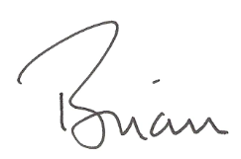

CHURCH HALLS BEING USED AGAIN

The first group to start using the halls since March was the Saturday morning Church Lego Club which was back in action from 31st October and is doing well with a small waiting list at time of going to print.
A new weekly Thursday morning group called the “Wee Wrigglers” was started in the big hall on Thursday 19th November by our Community Outreach Worker Lauren Jones. Lauren had picked up from prior discussion with Health Visitors that real problems of isolation and post-natal depression were being experienced by many mothers with children under 1 due to the restrictions on social interaction and cancellation of groups where young mothers would normally be able to socialise and experience mutual support. Such has been the level of demand that Lauren is running two “back-to-back” sessions for 10 babies in each group and may well introduce a third session.
The charity Gingerbread has weekly bookings on Thursdays after the “Wee Wrigglers” but using the small hall and will be providing its clients with baby massage classes. Gingerbread have confirmed bookings through to March 2021.
A previous external pre-school group is expected to start back soon. Greener Kirkcaldy are also booking the large hall for a day for a bike repair workshop by appointment.
All our activities within the Church building including Worship services take place within the constraints of current regulations. These regulations are subject to change in response to the current pandemic and all our activities will be subject to possible enhancement or curtailment accordingly.

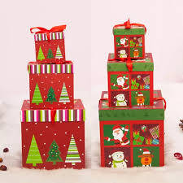
CHRISTMAS TREATS BOXES
Sadly it will not be possible to have our Annual Christmas Lunch in the Church Hall this year for those of a certain age. Instead, organisers Fiona Cunningham and John Bulloch will be packing boxes filled with Christmas goodies and these will be distributed to all who would in normal times be invited to the Christmas Lunch.
CHRISTIAN AID

Due to the Coronavirus pandemic, we were unable to conduct our usual collection in May this year, for the very valuable work of Christian Aid.
We are therefore, asking members to kindly make a donation to C. Aid at our Family Service in December, which is on Sunday 20th December, 2020.
Obviously 2020 has proved to be an extremely difficult year for C. Aid, however, even under all the challenging circumstances, they have had to contend with, they have continued to give support to communities and help transform the lives of vulnerable people overseas, where the need has been immense.
So, I appeal to all members to take this opportunity on Sunday 20th December, to make a donation for this vital work. Please put your donation in an envelope and mark it for C. Aid. Donations will also be gratefully received, if handed in any Sunday after the Family Service on the 20th December.
All donations will be very much appreciated.

FIONA CUNNINGHAM

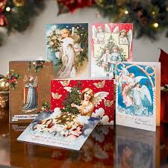
CHRISTMAS CARD DISTRIBUTION FOR 2020
Unfortunately the Covid rules mean that it will not be possible for members of the congregation to “hand out” Christmas Cards to other regular attenders within the confines of the Church.
A drop box marked “INTERNAL CARDS” will be available in the vestibule up until Sunday 13th December. After a few days “in quarantine” these cards will be sorted out and arrangements made to pass them on to their recipients and there will be no charge for this.
If you wish to send a card to “All at Torbain Church” please also use the “INTERNAL CARDS” box for this purpose.
If you would like cards to be delivered on your behalf to anyone (church members or non church members) who stay within Torbain or Templehall parishes (including Holly Braes Estate and Dunnikier Estate) a separate box will also be available marked “EXTERNAL CARDS”. It too will be in the vestibule up until Sunday 13th December and there will be a charge of 20p per card – proceeds going to church funds. Please put the name of the recipient(s) and the first line of their address on the envelope – no need to write Kirkcaldy or the postcode since they will be hand delivered on your behalf.
PARISH REGISTER

Deaths:

Jessie Bell, Marchmont Care Home, 26 May 2020

Kenneth Scott, Seafield Crescent, 6 June 2020

Ella O'Malley, Maree Place, 4th July 2020.
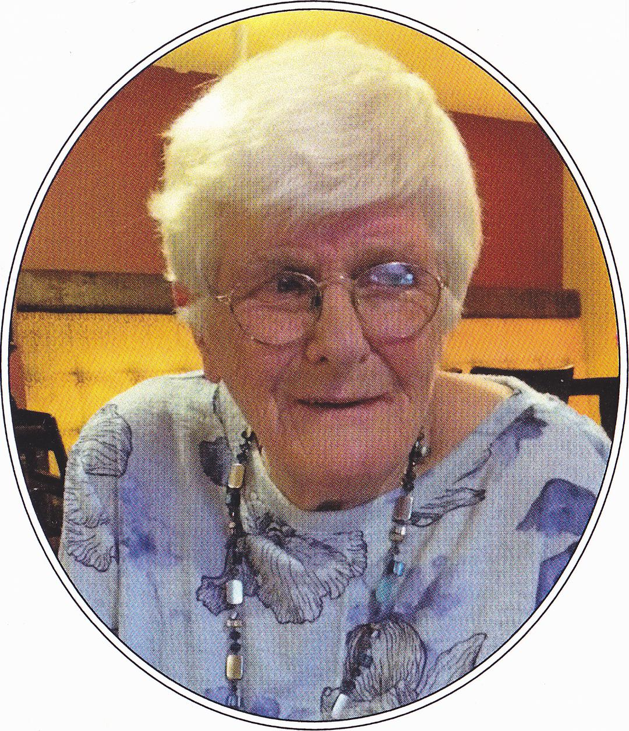
All who knew her were greatly saddened to hear of Ella’s death on 4th July. Both Ella and also Jessie Bell who died aged 101 on 26th May were recorded as joining Torbain Church on 7th February 1965 over 55 years ago. Ella was one of the founding members of Torbain Woman's Guild and was a Sunday School teacher for many years with Christian Thomson. She was a loyal supporter of Church events both in attendance and financially and regularly attended worship even when in failing health.
Ella also left a very generous bequest to Torbain Church which will be recognised by the dedication of the new screens to her memory.

(and just as we were going to print we heard more sad news)
Maime Stoddart (aged 100) Craigmount, 24th November 2020

Thanks from Kirkcaldy Foodbank
I would like to thank each and every member of the congregation for their ongoing support for Kirkcaldy Foodbank this year. The foodbank has faced a very challenging few months since March when we experienced a 33% increase in overall demand and a 70% increase in demand from families in particular. This coupled with a drop in donations as we all went into lockdown as well as a loss of many of our older volunteers who rightly heeded advice to stay at home resulted in a huge logistical challenge for us all. Despite that, through the power of prayer and a lot of hard work, we only had to close our doors for one day while we altered the physical layout of our premises to adapt to the challenges we had to face. We were so fortunate in that we had only moved into our new larger premises at Viewforth Church Hall a few weeks earlier and in the week of lockdown had taken delivery of 6 fridges and freezers, all of which were donated or purchased with grant funding. This meant that when local businesses had to close their doors and were looking for somewhere to donate food to, we were able to say a great big, yes please, and be able to store the items safely. God does work in mysterious ways as we all know.

We have been amazed at the continued support Kirkcaldy Foodbank receives from so many people across the town and the generosity that is shown to those in greater need than ourselves. As a frontline volunteer, I hear the stories of despair every week and am in awe of the resilience of some people as they face battle after battle in dealing with the poverty they find themselves facing. Covid 19 has added another burden to the burden the poor already carry is a quote I repeat often.

The work of the Foodbank will continue as long as we are needed and as we face an uncertain time for so many in employment and looking for employment I suspect we will be here for some time to come.
Joyce Leggate, Chair, Kirkcaldy Foodbank
TORBAIN & TEMPLEHALL CHURCHES
Journeying Towards A Positive Union

Over the past few weeks a considerable amount of work has taken place in order to construct the Basis of Union - the essential legal document which sets out the important matters which underpin the formation of the proposed new united church.

The Trustees of both churches have unanimously approved the document and it is currently being circulated to both congregations to enable individual members and adherents to cast their votes which will hopefully enable the union to proceed.

The proposed union has to be about much more than simply welding two churches together. It has to be about creating a new church in the North of Kirkcaldy that is fit for purpose for the 21st Century and which becomes firmly established as an integral part of the community it serves.
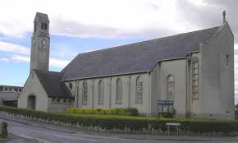

Torbain Lego Club
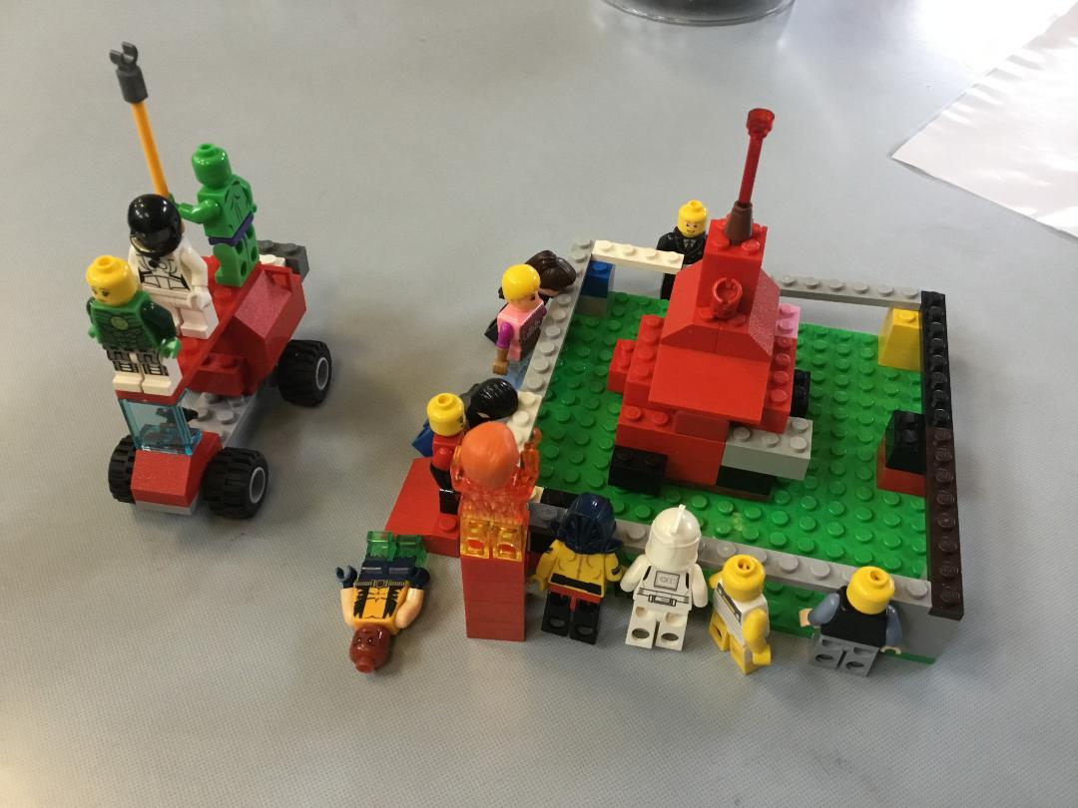
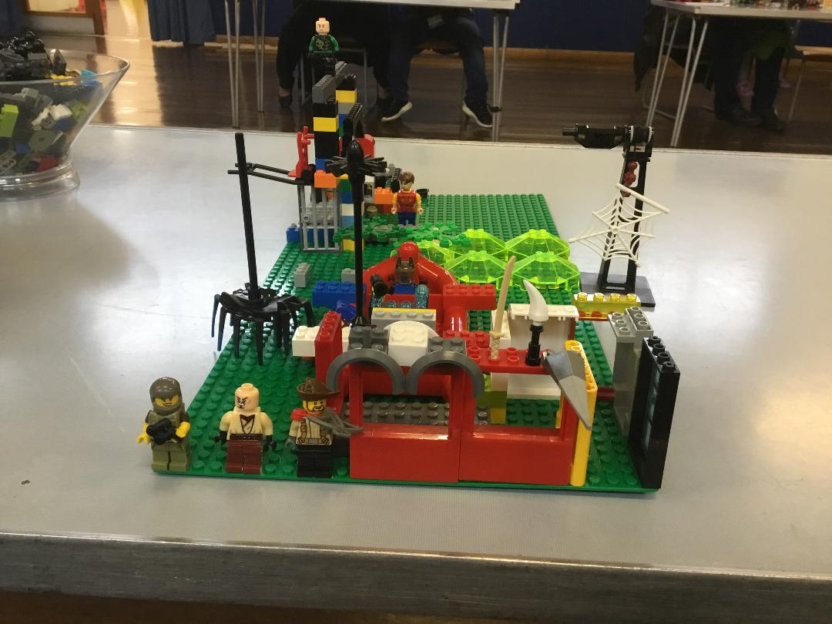
We were finally able to welcome some children back to the Lego Club on 30th October and were delighted to see 6 familiar faces back in the halls on the first day back. Unfortunately, we have to restrict the numbers but we are already up to capacity of 10 children and an accompanying adult enjoying the challenges of building models out of our huge selection of Lego bricks. As you can imagine, we are taking all precautions to keep everyone safe with only 5 children in each hall.
A Haunted MacDonalds
Thankfully, we have enough Lego to rotate the bricks used each week on a 3 weekly basis so that after it is sprayed with antiseptic spray it sits untouched for 3 weeks before using again. Elaine and I have a big clean-up to do after the session ensuring all surfaces are wiped down thoroughly throughout the parts of the building we use. It has been lovely to welcome back the children to something approaching normal after the long break since March and also to welcome some new faces.
Bonfire Night with engine standing by
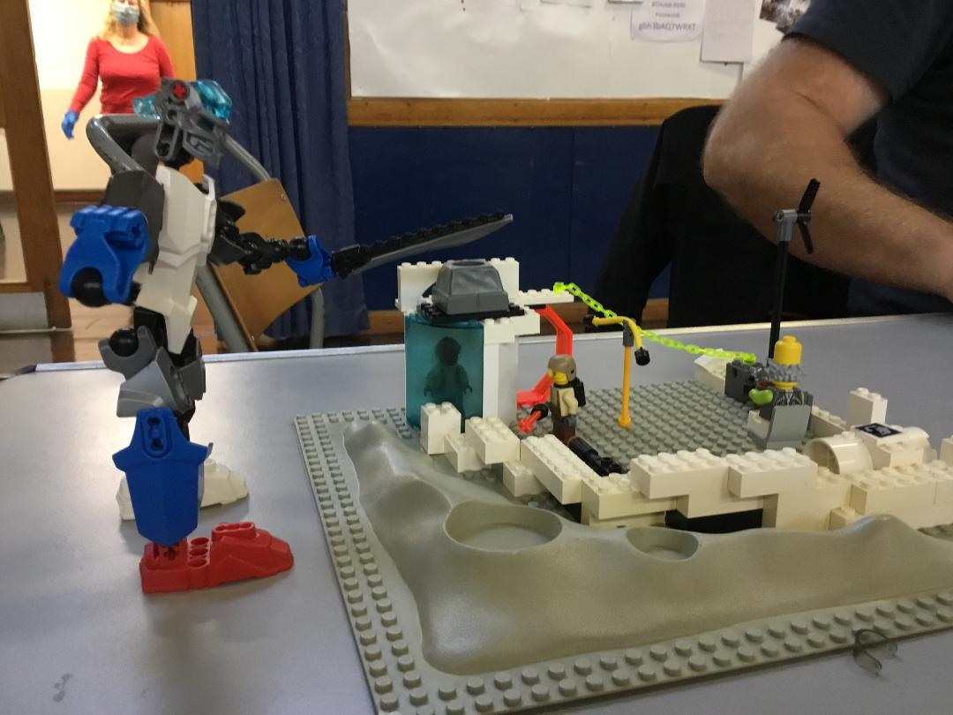
My next challenge is to think up the weekly themes for the challenges we set the children every week. No matter what we ask them to do they come up with amazing models every week. My grateful thanks go to Elaine Stoddart who comes and helps every week with running the club as we approach the 2nd birthday of Torbain Lego Club.
Space Wars with a captured Alien
Joyce Leggate
All involved in Pastoral Care would like to wish everyone a Merry Christmas and a Happy New Year.
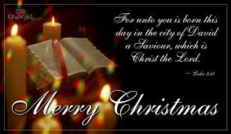

Money Matters

2020 what can we say? We have certainly faced a very challenging year. A year quite unlike any other in living memory!
In common with other churches and organisations Torbain has not fared as well financially this year and our overall income will be well down on recent years. It is encouraging however to see how resilient we have been during this time. I have to thank members for their continued support over the last six months or so. Weekly Free Will Offerings are almost in-line with last year. Also many of you supported the appeal to provide PPE for our brothers and sisters in Zambia – so far £1,400 has been sent to Jenny Featherstone (our missionary partner) to help with this.

Christmas Gift to God 2019
Details of this year’s Gift to God appeal will be delivered along with this edition of Torbain Times. An envelope will be provided for donations but these can also be made by internet banking. (Sort Code 80-16-84. Account No 10207261. Account Name Torbain Parish Church. Reference G2G20+your surname e.g. G2G20Benson)
Please give prayerful consideration to this year’s appeal.

On-Line Christmas Shopping - Get donations for Torbain
Please remember that Torbain Church can get free donations when you do your on-line shopping. You can access over 3,000 retailers through our easyfundraising site - including all of the High Street retailers. So you will find everything you need for Christmas and the rest of the year. Sign up on our site today, it's quick and easy. There is a link to the fundraising site on the Torbain Church website or you can go directly to: https://www.easyfundraising.org.uk/causes/torbainpc
Simply register then do all your on-line shopping through the site. Every time you make a purchase we get a donation from the retailer.
Also Amazon Smile makes a donation to us when you make your Amazon purchases through their Amazon Smile site. There is a link to Amazon Smile on the church website or you can go directly to:
https://smile.amazon.co.uk/
You need to select Torbain Parish Church of Scotland and then always access Amazon through through the Amazon Smile site.
If you do not shop on-line you can still help by asking other family members to sign up to these two sites.
John Bulloch - Treasurer

Blythswood Shoebox Appeal

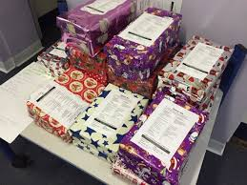
Despite the difficulties and restrictions of 2020 Torbain has once again taken part in the annual shoebox appeal. Blythswood send boxes with essential items and gifts to all ages of children and adults in Eastern Europe.
Although completed at short notice this year, Torbain donated 30 boxes – a wonderful total comparable to previous years
Many thanks to all. Irene and Ken Gilbert

