[](https://www.google.co.uk/url?sa=i&rct=j&q=&esrc=s&source=images&cd=&cad=rja&uact=8&ved=0CAcQjRxqFQoTCKDGk-bXgckCFcboDgodkdQI8w&url=https://blog.twitter.com/2012/a-new-day-a-new-bird&psig=AFQjCNEjQVRzENU07_-eu_i0naV8WDuY2g&ust=1447101625620688)

*Torbain Parish Church of Scotland*

*e-mail: torbain.church@gmail.com*

*website: www.torbainchurch.org*



**orbain imes**

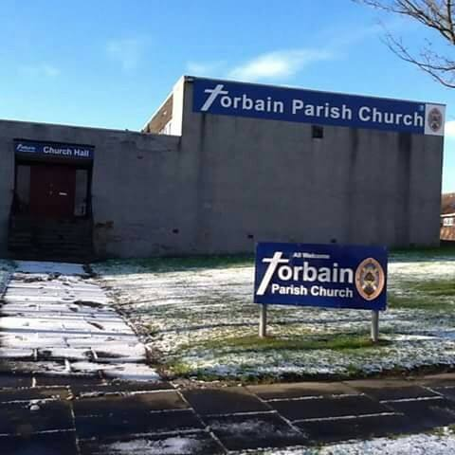

Torbain Parish Church, Carron Place, Kirkcaldy. KY2 6PS (Scottish Charity No. SC015807)

(Scottish Charity No. SC015807)

**Christmas Services**

**Friday 14 December - 6.30pm – Family Carol Service**

**Sunday 16 December - 11am – Nativity Service**

**Sunday 23 December - 11am – Carol Service**

**Monday 24 December - 7pm - Childrens Watchnight Service**

**10pm – Tea / Coffee / Sausage Rolls / Mince Pies (£2)**

**11pm – Carols 11.30pm Watchnight Service**

**Sunday 30 December – 11am – Shorter Service with Informal Communion**

#### December 2018 Issue 46

TORBAIN CHURCH - CONTACT LIST

**Minister - Rev. Ian Elston, 91 Sauchenbush Road, Kirkcaldy, KY2 5RN**

**Telephone - 01592 263015**

**Ordained Local Minister – Rev. Brian Porteous, ‘Kildene’, Westfield Road, Cupar KY15 5DS Telephone – 01334 653561**

**Session Clerk - Gordon Thomson, 28 Craigearn Avenue, Kirkcaldy, KY2 6YS Telephone - 01592 642735**

**Depute Session Clerk George Blair 262479**

**Depute Session Clerk Ken Gilbert 268970**

**Depute Session Clerk Barbara Currie 641704**

**Congregational Treasurer John Bulloch 570723**

**Presbytery Elder Gordon Thomson 642735**

**Gift Aid Convenor & Printing Graeme O’Malley 261905**

**Free Will Offering Convenor Fiona Cunningham 269297**

**Church Organist Gordon Thomson 642735**

**World Church Representative Liz Bradley 269520**

**Life & Work Promoter Wendy Sinclair 202246**

**Safeguarding Co-ordinator Joyce Leggate 264789**

**Safeguarding Co-ordinator Andy Leggate 264789**

**Property Convenor Bill McMurray 202173**

**Pastoral Care Elizabeth Pringle 266080**

**Hall Letting Ken Gilbert 268970**

**Church Flowers Ann Mackay 200144**

**\* * * * * * * * * * * * * * * * * * * * * * * * * * * * * * * * * * * \***

**CHURCH ORGANISATIONS – CONTACTS**

**Church Choir - Gordon Thomson 642735**

**The Friendship Group - Graeme O’Malley 261905**

**Over 60s Club - Rose Stewart 261230**

**Bairns,a Blether and a Brew - Laura Dryburgh bairnsbletherbrew@outlook.com**

**Girlguiding Rangers - Marjory Aird 07764447610**

**Girlguiding Guides - Sharon Thomson 642735**

**Girlguiding Brownies (Tuesday) - Liz Bradley 269520**

**Girlguiding Brownies (Wednesday) - Irene Fairgrieve 268787**

**Girlguiding Rainbows - Susan Morton 205397**

**The Scouts/ Cubs / Beavers - Andy Leggate 264789**

**(meeting in Scout Hall)**

Elders’ Districts

District No. & Location Elder

1. Lindores /Carron L Bradley 269520
2. Otterston / Birnam M Knight 266915
3. Davaar / Lindores M Forrester 571920
4. Torbain / G’nloanings J Connor (ex-d)
5. Greenloanings J Leggate 264789
6. Craigmount W Sinclair 202246
7. Black/Redcraigs B&C McMurray 202173
8. Glamis B MacGregor 200002
9. Chapelhill (North) M Rowan 200345

10. Broom / Chapelhill L Herd 269727

District No. & Location Elder

11 Glens G Mowatt 202550

12 Newliston H White 261934

13 Dunnikier (1) A Stalker 206053

14 Dunnikier (2) E Pringle 266080

15 Hayfield G O’Malley 261905

16 Kirkcaldy (East) J Gallo 267561

17 Kirkcaldy (West) B Currie 641704

18 Kirkcaldy (North) F Cunningham 269297

19 Oriel Road K Gilbert 268970

20 Sauchenbush G Blair 262479

Dear Friends,

Can I wish everyone a very happy and peaceful and thoughtful and joyous Advent and Christmas. This is one of the times of year that our Christian Faith – so often forgotten by so many – is at the centre of festivities as we remember and give thanks for the child in the manger; Jesus Christ, God incarnate.

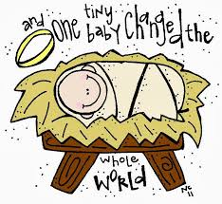Imagine; God coming to earth as a helpless baby, all to show His love for us! Truly a time for worship and praise and celebration.

Jesus came to give us hope and show just how much God loved us. He taught us to love God, love one another and love ourselves (wouldn’t the world be a wonderful place if we could put these into practice). He taught us to love our enemies and to look for and love the lost. We have all been someone’s enemy, we have all been lost but the glorious message of Christmas is that God loves me and you wherever we are and whatever we have done.

The message for Advent and Christmas is one of Hope. Hope in a God that loves us. Hope in a God that loves us so much he became one of us. Hope in a God who has overcome death. Hope in a God who will never leave us. Hope in a God that binds us together in love for Him.

A message to live out and share.

May I wish you all a very happy and peaceful and joyous Christmas.

Ian

TORBAIN CHURCH ADDRESS

49 years after the Church building opened, Royal Mail have now given us an official postal address!

It is:

Torbain Parish Church,

Carron Place,

KIRKCALDY,

Fife.

KY2 6PS

Our Church e-mail address is: [torbain.church@gmail.com](mailto:torbain.church@gmail.com)

Our Church website is [www.torbainchurch.org](http://www.torbainchurch.org)

Personal Message from Ian:

Can I take this opportunity to thank everybody for their prayers and cards over the past few months. It has been very much appreciated. A word of thanks also to Brian, Tilly, Fiona, Gordon and others whose preaching, pastoral work, taking of funerals, organising and arranging have ensured a minimum of disruption with a maximum of skill, conscientiousness and dedication.

DATE FOR YOUR DIARY

SUNDAY 28th APRIL 2019

* Special Service at 11am to Commemorate 50 Years of Torbain Church Building
* Guest Preacher – former minister – Rev. Peter Macdonald
* Buffet Lunch – Dean Park Hotel – 1 for 1.30pm.
* Lunch Tickets £10 – contact Finance Team if you want to save up each week.

**Blythswood Shoebox Appeal**

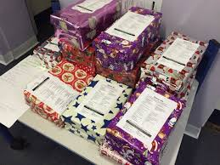This is Blythswood Care's 25th year sending gifts to some of the poorest people in Eastern Europe. In that time over 2 million boxes have been distributed. The Christmas boxes will be sent to eight countries including Albania, Kosovo, Romania and Ukraine.

This year Torbain Congregation have donated 25 boxes.

Many thanks to all who contributed.



Lego Club

Joyce Leggate is planning to start a Lego Club which would meet in the church possibly on Saturday afternoons. Children of all ages would be welcome to come along with an adult who can be a parent or guardian, or indeed any other adult relative or close family friend. It will be an opportunity to have fun in a creative environment. Entry £2 per family which will go towards providing refreshments, prizes and the purchase of more Lego. Joyce is also looking for donations of any unused Lego or Duplo.

More information will soon be appearing on the Torbain website [www.torbainchurch.org](http://www.torbainchurch.org) and our social media sites.

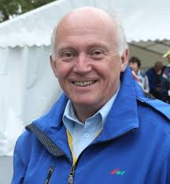Brian’s Message

*No one lights a lamp and puts it under a bowl; instead he puts it on a lampstand, where it gives light to everyone in the house. Matthew 5:15*

Well you cannot have missed our new notice board and wasn’t it great to see our Remembrance Service promoted so appropriately! Watch that space for all forthcoming attractions. Of the many wonderful things about Torbain Parish Church, one of the most important is our location right at the heart of the community. But you know, I think like many churches we have been guilty of hiding our light under a bowl. Not any more……

Especially in these dark days of winter and as we look forward to Christmas, we need to be the brightest of lights in and for our community. Most of the Christmas card depictions of the stable in Bethlehem show a warm glow which was probably far from historic fact but we can let all know that our church is a warm and welcoming place for everyone at Christmas and throughout the year.

Reaching out into the community that surrounds us is an important part of our church strategy and with growing initiatives like Bairns a Blether and a Brew, we have taken some steps forward during the past year. Equally, the church buildings are increasingly well used by community organisations. The Kirk Session has plans, as we move into our 50th Anniversary year, to do much more in terms of meeting the needs of our community and more will be said about that later.

So as we prepare to welcome again Jesus the Light of the World, let us do our part to reach out with that light and love to a needy community and a needy world. That way we will certainly not be hiding our light under a bowl and we will be a beacon of God’s glory in our wee bit of Kirkcaldy.

May the light and love of Jesus warm and inspire you all at this Christmas time and into the New Year,

Brian

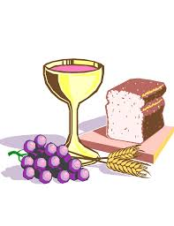COMMUNION DATES

Please note that Holy Communion will be held on the following Sundays:

2 December 2018; 30 December 2018 (Informal Communion);

6 January 2019 and the **FIRST** SUNDAY OF EACH MONTH thereafter.



**Christmas Gift to God 2018**

A letter with details of this years Gift to God appeal is being delivered along with this edition of Torbain Times. In 2018 the Church has had considerable costs and has also embarked on major improvements to the building. Costs in 2019 are likely to be similar or higher. Your gift will help with these costs and can be made using the envelope provided or by internet banking. Please give prayerful consideration to this years appeal.

**On-Line Christmas Shopping - Get a donation for Torbain**

Don't forget Torbain gets FREE donations with easyfundraising when you do your Christmas shopping online! With over 3,000 retailers to choose from, you'll find all the stocking fillers you need this Christmas. Sign up on our site today, it's quick and easy. There is a link to the fundraising site on the Torbain Church website or you can go directly to: [https://www.easyfundraising.org.uk/causes/torbainpc](http://email.easyfundraising.org.uk/HP?b=FU732CgC-_lfXZ6y5Z6fOJsjElNza-m6UI4Yx_5q_1aBJ_WGck3z57xpLcbrwmMZ&c=MRmLucMvNZSBqWcNkR-T0A)

Every time you buy online using our fund raising site we get a donation from the retailer.



**Gift Aid** This is the scheme where the tax man can give us a top up of 25 pence in every pound donated by you. This can only be claimed if you are a tax payer. However please note that if your spouse pays tax, and you do not, Gift Aid can still be reclaimed. If you have not signed a Gift Aid Declaration already please consider completing one. Forms are in the vestibule but can also be obtained from your elder or downloaded from the Church website.

PARISH REGISTER:

Baptism:

Skye Elizabeth Denise Swan

Deaths:

Tom Mackie of Turriff Place

Molly Taylor of Braids Road

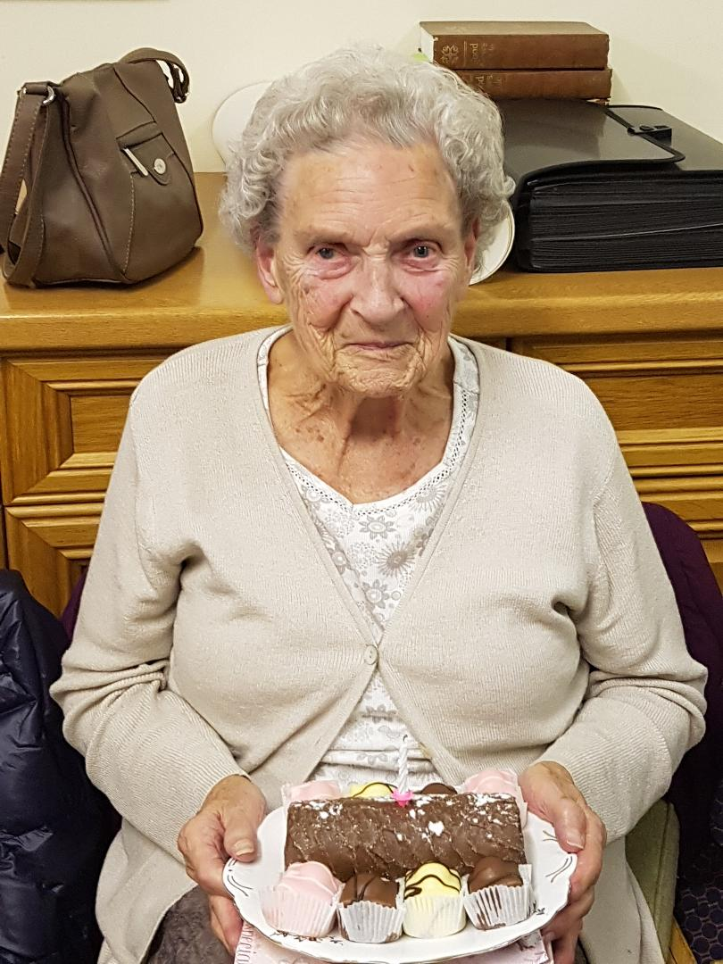Happy Birthday to:

Congratulations to Jessie Gray who was 90 on Tuesday 13th November. The Friendship Group presented her with a gift and cake with a candle.

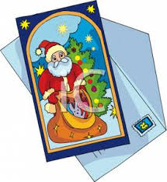ONE CARD FOR ALL

TAKING THE STRAIN OUT OF CHRISTMAS CARDS

AND HELPING A GOOD CAUSE

Following an excellent suggestion from one of our members who is no longer physically able to distribute her Christmas Cards to her friends in the Church there is now an alternative option for anyone in a similar position.

This alternative is to send ‘ONE CARD FOR ALL’. This one card would be to Everyone in the Church. So if you are no longer able to come to Church yourself then it could be given to a friend or your Elder to bring in on your behalf. Everyone is invited to avail themselves of this service and any card delivered in this way will be displayed in the vestibule for all to see.

A Donation Box has been placed in the Vestibule for Kirkcaldy Foodbank for those who have used this service to make a donation, if they so wish. Obviously anyone can make a donation to the Kirkcaldy Foodbank, regardless of whether or not they have opted to utilise this service.

Pastoral Care Christmas Lunch

Tuesday 18 December from 1pm to 3pm.

All involved in Pastoral Care would like to wish everyone a Merry Christmas and a Happy New Year.

Care Home Services

Monday 17 December

1.45pm Chapel Care Home

2.30pm Ostlers House

**Some Christmas Reminders**

May the Christmas GIFTS remind us of God’s greatest gift, His only Son.

May the Christmas CANDLES remind us of Him who is the “Light of the world.”

May the Christmas TREES remind us of another tree upon which he died.

May the Christmas CHEER remind us of Him who said, “Be of good cheer.”

May the Christmas FEAST remind us of Him who is “the Bread of Life.”

May the Christmas BELLS remind us of the glorious proclamation of His birth.

May the Christmas CAROLS remind us of the song the angels sang,

“Glory to God in the Highest!”

May the Christmas SEASON remind us in every way of Jesus Christ our King!

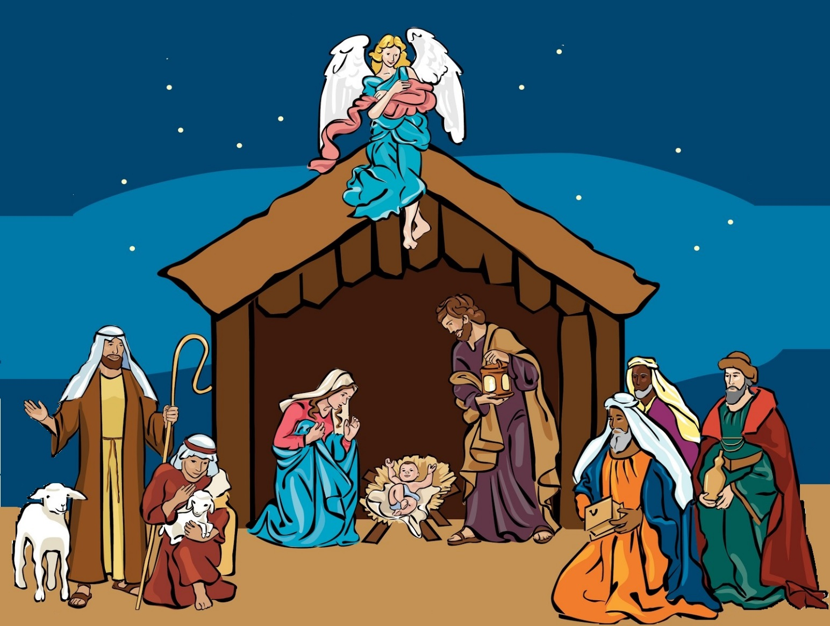

**Family Carol Christmas Story**

**Singing Nativity Service**

**Friday, 14 December Sunday, 16 December**

**6.30pm 11.00am**

**.** **For children of all ages Come along to this retelling of the**

**(and adults of all ages too!) nativity story especially for families,**

**featuring well-known carols and readings.**

**Torbain Parish Church, Carron Place, Kirkcaldy. KY2 6PS**

Recipe For A Happy New Year

Take twelve whole months.

Clean them thoroughly of all bitterness, hate, and jealousy.

Make them just as fresh and clean as possible.

Now cut each month into twenty-eight, thirty, or thirty-one different parts, but don't make up the whole batch at once.

Prepare it one day at a time out of these ingredients.

Mix well into each day one part of faith, one part of patience, one part of courage, and one part of work.

Add to each day one part of hope, faithfulness, generosity, and kindness.

Blend with one part prayer, one part meditation, and one good deed.

Season the whole with a dash of good spirits, a sprinkle of fun, a pinch of play, and a cupful of good humour.

Pour all of this into a vessel of love.

Cook thoroughly over radiant joy, garnish with a smile, and serve with quietness, unselfishness, and cheerfulness.

You're bound to have a happy new year.