[](https://www.google.co.uk/url?sa=i&rct=j&q=&esrc=s&source=images&cd=&cad=rja&uact=8&ved=0CAcQjRxqFQoTCKDGk-bXgckCFcboDgodkdQI8w&url=https://blog.twitter.com/2012/a-new-day-a-new-bird&psig=AFQjCNEjQVRzENU07_-eu_i0naV8WDuY2g&ust=1447101625620688)

*Torbain Parish Church of Scotland*



**orbain imes**

## EASTER ISSUE

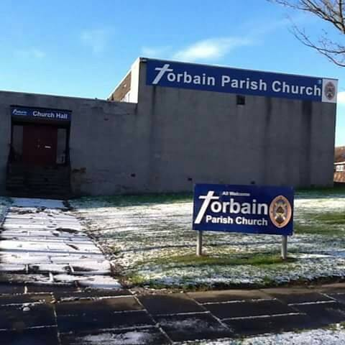

Torbain Parish Church, Lindores Drive, Kirkcaldy (Scottish Charity No. SC015807)

(Scottish Charity No. SC015807)

**Easter Services**

**Friday 30th March - 7pm** *Good Friday Service*

**Sunday 1st April - 11am** *Easter Day Service with Family Communion*

#### March 2018 Issue 45

TORBAIN CHURCH - CONTACT LIST

**Minister - Rev. Ian Elston, 91 Sauchenbush Road, Kirkcaldy, KY2 5RN Telephone - 01592 263015**

**Session Clerk - Gordon Thomson, 28 Craigearn Avenue, Kirkcaldy, KY2 6YS Telephone - 01592 642735**

**Depute Session Clerk George Blair 262479**

**Depute Session Clerk Ken Gilbert 268970**

**Depute Session Clerk Barbara Currie 641704**

**Clerk to Congregational Board Betty MacGregor 200002**

**Congregational Treasurer John Bulloch 570723**

**Presbytery Elder Gordon Thomson 642735**

**Gift Aid Convenor & Printing Graeme O’Malley 261905**

**Free Will Offering Convenor Fiona Cunningham 269297**

**Church Organist Gordon Thomson 642735**

**World Church Representative Liz Bradley 269520**

**Life & Work Promoter Wendy Sinclair 202246**

**Safeguarding Co-ordinator Joyce Leggate 264789**

**Safeguarding Co-ordinator Andy Leggate 264789**

**Property Convenor Bill McMurray 202173**

**Pastoral Care Leader Elizabeth Pringle 266080**

**Hall Letting Ken Gilbert 268970**

**Church Flowers Ann Mackay 200144**

**\* * * * * * * * * * * * * * * * * * * * * * * * * * * * * * * * * * * \***

**CHURCH ORGANISATIONS – CONTACTS**

**Church Choir - Gordon Thomson 642735**

**The Guild Please note that due to illness there will be no formal meetings until further notice.**

**Anyone requiring further information meantime should contact Wendy Sinclair or Graeme O'Malley.**

**Over 60s Club - Rose Stewart 261230**

**Bairns,a Blether and a Brew - Laura Dryburgh bairnsbletherbrew@outlook.com**

**The Guides - Sharon Thomson 642735**

**The Brownies (Tuesday) - Liz Bradley 269520**

**The Brownies (Wednesday) - Irene Fairgrieve 268787**

**The Rainbows - Susan Morton 205397**

**The Scouts/ Cubs / Beavers - Lorraine Reilly 201089**

**(meeting in Scout Hall)**

Elders’ Districts

District No. & Location Elder

1. Lindores /Carron L Bradley 269520
2. Otterston / Birnam M Knight 266915
3. Davaar / Lindores M Forrester 571920
4. Torbain / G’nloanings J Connor (ex-d)
5. Greenloanings J Leggate 264789
6. Craigmount W Sinclair 202246
7. Black/Redcraigs B&C McMurray 202173
8. Glamis B MacGregor 200002
9. Chapelhill (North) M Rowan 200345

10. Broom / Chapelhill L Herd 269727

District No. & Location Elder

11 Glens G Mowatt 202550

12 Newliston H White 261934

13 Dunnikier (1) A Stalker 206053

14 Dunnikier (2) E Pringle 266080

15 Hayfield G O’Malley 261905

16 Kirkcaldy (East) J Gallo 267561

17 Kirkcaldy (West) B Currie 641704

18 Kirkcaldy (North) F Cunningham 269297

19 Oriel Road K Gilbert 268970

20 Sauchenbush G Blair 262479



Dear Friends

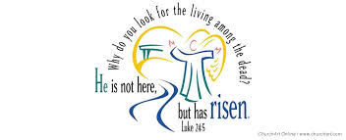Eggs and chicks and bunnies; the Easter Bunny, chocolate – we have almost managed to completely erase the Easter story from Easter! Just as Christmas has become a non-religious consumer fest for millions so Easter is gradually becoming, or has already become, a Christ free zone for the vast majority of people. And this is tragic. Because Easter without Christ is like a box with no chocolate egg inside – empty. And just as chocolate is tasty but never fills you up in the way a good meal does, Easter without coming to worship, without remembering the story of the crucifixion and resurrection, can become nothing more than a chocolate fest for children young and old.

We have a wonderful, marvellous Earth shattering story to share. A monumental, world altering event that changed history - and still does. We live through Christ in the hope-giving, life-renewing Spirit that encourages and enthuses and calms and consoles and challenges and provokes.

Jesus, the Son of God, lived and died and rose again. Death defeated. Love reborn. Hope for today and tomorrow made sure and certain. We all sometimes forget the wonder of Easter. We all sometimes forget the hope found in Christ. We all sometimes forget that God loved us so much that he died for us.

So this Easter take time to remember and worship and share as we thank God for the gift of His Son Jesus who lived and suffered and died and rose for me and you.

Blessings

Ian​

PARISH REGISTER:

Deaths:

Margaret Gray of Craigmount

Mrs Ross of Greenloanings

Betty Lewis of Greenloanings

Ann Guiney of Chapelhill

Margaret Watson of Whytemans Brae

Drew Forrester of Prestonfield Drive.

Our prayers are with the family and friends of the above church members who have passed away since the publication of the last edition of the Torbain Times. All played a significant part in the life of the church and made immense contributions to Torbain in ways too numerous to list. Torbain is indebted to their service and we thank God for their lives

Margaret Gray served as an elder having been ordained at Torbain in May 1976. She was active in the Guild, sang with the choir and was heavily involved in the Sunday school. There must be many, many men and women in Kirkcaldy who were taught by Margaret whose faith shone through her life.  Margaret ​(and her late husband Bert) were part of the backbone and foundation of Torbain: establishing it in the community and working hard in attracting and welcoming people here. Margaret was unable to attend church over the last few years of her life but she was always eager for news of what was happening. She passed away peacefully after a short illness.

IONA APPEAL

A soup and sweet lunch will be held on Sunday 8th April after morning worship. Proceeds will be in aid of the Iona Refurbishment Appeal “Sanctuary and Light”. Phase 1 of the Project is underway at the moment and Phase II is scheduled to begin later this year. Lunch tickets will be priced at £3.00 per person. Anyone wishing to make a donation to this Appeal can do so via Fiona Cunningham. Any donation will be gratefully appreciated.

ANNUAL CONFERENCE

All members of the congregation are invited to attend the Torbain Church Annual Conference which will be held in the large hall after morning service on Sunday 22nd April 2018. Brian Porteous will give a presentation on our Strategy Plan. This is an opportunity to have your say in the future of our church and we hope as many as possible can come.

**Money Matters**

**Christmas Gift to God 2017**

A very big THANK YOU to all who made a donation to the 2017 Christmas Appeal. Over £1,500 was raised and as we can claim Gift Aid from HMRC on some of donations the final total will be around £2,000.

**Free Will Offering**

Members are asked to give prayerful consideration to increase FWO giving by at least 3%. This will ensure that the congregation’s finances remain robust and that the Church here in Torbain remains viable.

**Maintenance Fund**

This fund is used to maintain the Church buildings in good order. Over the last few years donations have fallen and there is insufficient funds to pay for repairs and ongoing maintenance. If you do not already contribute to this fund please consider doing so. If you already donate please consider increasing your donation.

**Standing Orders**

If you make your Free Will Offering or Maintenance donation by Standing Order please remember to increase these.

**Torbain Benevolent Fund**

You may be aware that for many years now Torbain has had a small Benevolent Fund. This is used by the Minister (with the support of the Session Clerk and Treasurer) to make emergency grants or donations to individuals in need, charities and good causes locally, nationally or internationally.

Donations can be passed to either Ian Elston, Gordon Thomson or John Bulloch. Alternatively they can be placed in an envelope and marked “Donation to Benevolent Fund” and put in the plate on a Sunday morning. If you make a donation to this fund it will only ever be used for benevolent purposes.

**Bairns, a Blether and a Brew**

* **Parent/Carer and Baby Group**
* **Mondays 1030-1130 in the Church Hall**
* **Children aged 0-3 years**
* **Donation at the door**
* **Facebook @bairnsbletherbrew**
* **Twitter and Insta @bairnsgroup**

**Reaching Out to the Workplace**

Firstly an apology – as I write this you are still stuck with me while the powers that be decide what they want me to do next. I am just so grateful for your on-going support and encouragement and the unstinting guidance Ian continues to provide.

Even if I move from Torbain, in one sense I may not actually be far away because Workplace Chaplaincy Scotland, with whom I serve as a voluntary chaplain, has asked that I have an involvement in the Fife Retail Park. I am already chaplain to the Royal Mail and Fire and Rescue Service in Cupar.

Work Place Chaplaincy grew out of the traditional heavy industries of Scotland. As the industrial profile of the country changed so “Work Place Chaplaincy Scotland” emerged from the “Scottish Churches Industrial Mission” to take up the new challenges of providing pastoral and spiritual support to business, commerce, local government, retail sectors and agriculture.

Work Place Chaplaincy aims to meet people where they are – in the setting of their daily work and individual lives.  The chaplain is available to all from the managing director to the new-start apprentice.

Workplace Chaplaincy Scotland enjoys significant financial support from the Church of Scotland but is a non-denominational body with people from many Christian denominations serving. Some Chaplains are ordained ministers but the majority of the volunteers are simply committed Christians who want to reach out in love to serve those in the workplace.

As chaplains we understand that chaplaincy is not about making converts, but offering respect, compassion and care to people from all cultural and belief backgrounds. Nonetheless, partnerships between WPCS and local churches are an important aspect of our way of working and I see exciting possibilities for this in Kirkcaldy.

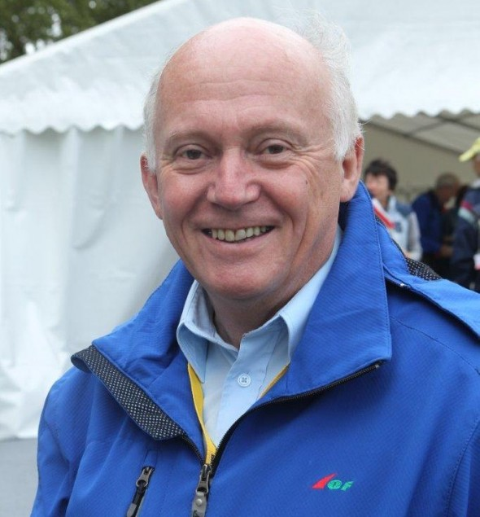Chaplains go through an interesting, comprehensive and relevant training programme covering areas like, depression, conflict in the workplace, listening skills, confidentiality, dealing with trauma, bereavement, equality and diversity and ethical practices in the workplace. Some chaplains also train to be part of a disaster response team in the event of any major civil emergency. For example, at the Clutha helicopter crash there was a team of some 12 chaplains on duty.

I see this form of ministry as vital in a world where we are finding it increasingly difficult to get people to come to church. In reaching out to where people spend considerable parts of their lives and experience life’s challenges and problems we are doing not only what Jesus wants us to do but actually we are following what he did himself.

If you would like any further information about WPCS then please ask me.

Brian Porteous